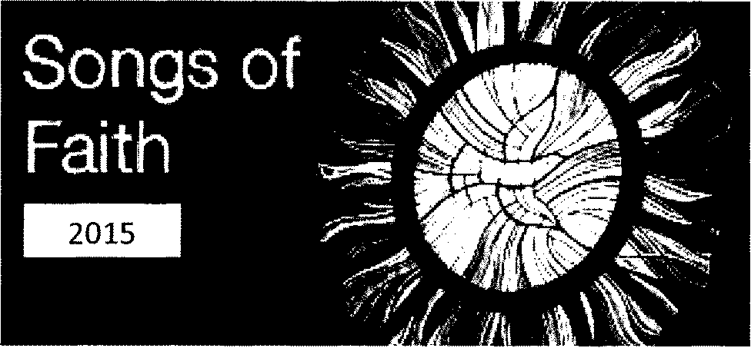
In November 2013 you may recall we hosted two music projects for young people in the
Diocese. This year we are offering one project to bring together young people aged 13-18
from schools and parishes across the whole diocese to work with renowned liturgical music
composer lan Callanan. (www.iancallanan.com)
lan will lead two workshops and then the rehearsal and concert on the following dates:
Workshop one: Sunday 18th October 2:30pm - 5:30pm
Workshop two: Sunday 8th November 2:30pm - 5:30pm
Rehearsal and concert: Sunday 22nd November begin 2:30pm Concert: 7:00pm
All workshops and the concert will take place at Our Lady Crowned Church, Mayfield
We need you to:
Invite young people aged 13-18 (second level students) to join the choir
Invite young people aged 13-18 (second level students) who are musicians to join the band
We are also seeking young adults 18-35 who are musicians to join the band, singers to join
to be our soloists and/or join our support choir. Please invite them too!
PLEASE TELL ALL YOUR PARISH MUSICIANS AND CHOIRS ABOUT THIS PROJECT
Also, we need some willing volunteers to help with supervision, catering, administration,
for the workshops and concert day. (no musical ability necessary!)
If you are interested or would like to know more about the project before committing to
participating as musician, singer or volunteer contact Sr Karen 021 4537601 and/or come
to a meeting on THURSDAY 24th SEPTEMBER at the Pastoral Development Office in
Ballyphehane (located in the parochial house in the grounds of the Church)
SONGS OF FAITH 2015
is a project of the Cork and Ross Pastoral Development Office
for young people

